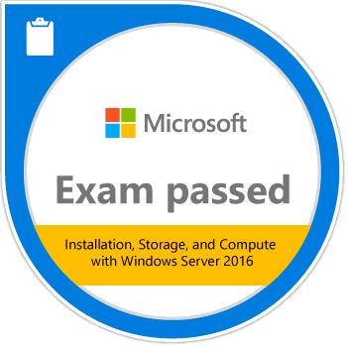 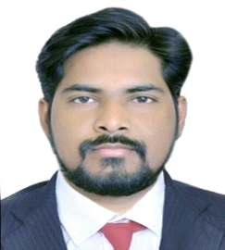

**Prince Prasad**

**Sr, System Administrator**

Mail: Princer60@gmail.com

Mobile: +91-9099621156 / 7016069434

Skype – Prince.prasad888 / Prince.Prasad2013@Hotmail.com

Vadodara, Gujarat

* **Professional Summary**
* 8.8+ Years of IT Experience in System Administrator, knowledge About AWS , Linux , AD, DHCP, DNS, File server ,Office 365, Skype Application support, Customer Support, and Managing the Big fix Console .
* **Certification: -**
* **Microsoft Certificates ID: MS0989293211**
* **Technical Skill: -**

**AWS :-**

* Deployed, automated, maintained and managed AWS cloud based production system, and providing to remote support in US .
* To ensure the availability, performance, scalability and security of productions systems
* Using the AWS Inventory for monitoring server , Making the tickets As per SLA ,and Monitoring the server thru since Logice Software.
* Working on Ticket tool like Service Now, knowledge of below Services EC2, RDS, EBS, S3, IAM, VPC, AMI , Load balancer
* Doing commission ,Decommission of cloud server, checking monitoring alert of server.
* **Patch Management thru Big Fix Console**-- Deployment MS patches on Desktop & Server, and taking inventory , Monitoring and auditing of access, Data published via web reports.
* **Linux ---**Installationand configuration , creating users and groups, assigne to rights and groups, checking logs and process.
* Configuration management for web /Application server Apache,
* willingness to work on flexible hour for production, and call support 24/7 Environments.
* Worked with other administrators to strategize and improve systems/productivity.
* **Server----**System Administrator, including analyzing, installing, maintaining, hardware, software, peripherals,
* Installation and Configuration of Microsoft Server 2008, 2012, 2016.

Knowledge of Active Directory, DHCP, DNS, Group Policy, Adding users,

* **Work Experience Summary: -**

|  |  |  |  |
| --- | --- | --- | --- |
| **Company Name** | **Location** | **Duration** | **Designation** |
| * **Om Kala Services (Client–Adyta Birla)** | **Baroda** | **23 May 2011 to 31 Oct 2012** | **Assistant IT Engineer** |
| * **On word Services (Client–Adyta Birla)** | **Baroda** | **1Nov 2012 to 31 May2016** | **IT Support Engineer** |
| * **IT Source (Client – Minacs)** | **Baroda** | **1 Jun to 2016 10 April2018** | **Desktop Engineer** |
| * **Concentric Services Pvt. Ltd.** | **Baroda** | **11Apr2018to 22Dec2019** | **Sr. Technical Support IT Operations** |
| * **Devitpl** | **Ahmadabad** | **1Jan2020 till now** | **System Administrator** |

* **Job role & Responsibility**
* Logging calls with Vendor & follow-up for end-to-end resolution of issues
* Co-coordinating with various teams for following offsite process related to LTO tapes
* Data Center Management
* Physical installation, movement & removal of server, network & voice hardware
* of racks ( 14u, 21u, 38u & 41u, as per Client requirement)
* Making ready Win Serve 2k8, 2k12 as per requirement
* Performing desktop/laptop encryptions & coordinating with various teams troubleshooting of same
* Installing & making ready base setup for Linux
* Co-coordinating & troubleshooting with respective Team for various issues related to user email accounts of Exchange, Mithi, Zimbra.
* Handling Level 2 calls related to various software of programs running at site
* Resolving tickets keeping in mind the SLA
* Install, upgrade, support and troubleshoot for printers, computer hardware and any other authorized peripheral equipment.
* Troubleshoot and resolve issues with voice communications, when possible from the Help Desk..
* Utilize and maintain the helpdesk tracking software.
* Install, test and configure new workstations, peripheral equipment and software.
* Maintain inventory of all equipment, software and software licenses.
* Report issues to the Service Desk for escalation.
* Manage PC setup and deployment for new employees using standard hardware
* Responded to server down alerts in a timely manner and brought them up via
* Logging calls with Vendor & follow-up for end-to-end resolution of issues
* Installation & troubleshooting of SCCM software on Client
* Collecting logs, Analyzing same under supervision of Server Team
* Creation of SUG groups / Addition-Deletion of machines in console
* Part of team responsible for of latest VERITAS software & up gradation of old VERITAS software
* **Education: -**

|  |  |  |
| --- | --- | --- |
| **Name of Examination** | **Passing**  **Year** | **Board /University** |
| **S. S. C** | **2005** | **Board of secondary Education – Rajasthan** |
| **Hardware & Networking** | **2006** | **Venus Engineering institute --Gujarat** |
| **Diploma in U-NET** | **2008** | **Phoenix Education--Gujarat** |
| **H. S. C** | **2010** | **Bihar school - Examination board** |
| **VM Ware (Beginners Certification)** | **2018** | **Gujarat** |
| **Windows 2016,MCSE, Certification** | **2019** | **Gujarat** |
| **AWS Certified Solutions Architect** | **2020** | **Gujarat** |

* **Personal Details: -**
* Date of Birth : 21-12-1989
* Father’s Name : Bhirgunath Prasad
* Sex : Male
* Nationality : Indian
* Marital Status : Married
* Languages Known : English, Hindi & Gujarat
* Hobbies & Interest : Listening to Music,
* **PASSPORT DETAIL**
* Passport No. : S1362860
* Place of Issue : Patna
* Date of Issue : 06-06-2018
* Date of Expiry : 5-06-2028

**Declaration**

I, Prince Prasad, hereby declare that the information contained herein is true and correct to the best of my knowledge and belief

Prince Prasad Vadodara, Gujarat